**2.6.1 Functional Requirements**

1. A fully functional app that controls work-flow with servers, APIs, doctors, Staff ,and patients in organized, accurate, and quick methods.

2. The System must store all required data about doctors and staff (ids, info, and assigned patients), patients (ids, info, medical history, medical reports, and treatments).

3. A Speech Recognition System to record the conversation between doctor and patient.

4. A Server that stores data and Machine Learning Models.

5. API to guarantee communication between server and application.

6. A fully functional and tested Machine Learning Model that analyzes texts to extract symptoms and diagnose diseases.

7. A system to specify proper treatments based on diagnosing.

8. A user interface that enables patients and doctors to create accounts, add medical records, check their medical history.

9.A user interface that enables employees to do their jobs such as a receptionist

10. The doctor and the patient must be able to start a diagnosis process.

11. The Application must forward the description text of the symptoms to the model for analysis through an API

13. The doctor and the patient must be able to receive the generated report with the full diagnosis report and treatment and confirm it through an API.

14. Web service to be used as a website or/and mobile app.

15.The ability of the system to monitor to alert or predict any dangers coming from the patient or to detect any medical errors.

16. The ability of the guardian to monitor the patient and warn him of any dangers.

17.The patient's ability to book, pay costs, and order medications online.

18.The system's ability to generate instant reports to evaluate performance against targets to assist managers.

**Functional requirement 9**

* **Description**

Two types of objects are created for two types of patients, which are the normal psychological or mental patient and the serious patient, to classify them and store their data.

* **Input**

Health file, patient data, medical history, and any other diagnoses.

* **Processing**

Using artificial intelligence algorithms, after entering patient information, health file, and diagnosis, their classification begins after pressing the patient registration button or the update data button.

* **Output**

Categorize the patient with the correct list or classification and save it in the system to be used in treatment and prediction.

**Functional requirement 13**

* **Description**

Create objects for each employee working inside the hospital to enter, modify and display his data, in addition to the possibility of deleting it.

* **Input**

His details and CV, if any.

* **Processing**

After filling in the data entry fields and uploading the CV by pressing the Upload CV file button, the data is confirmed and saved in the system after pressing the submit button or saving the changes by pressing the Update or Delete button after searching for the employee in the search field.

* **Output**

Employees are saved in the system.

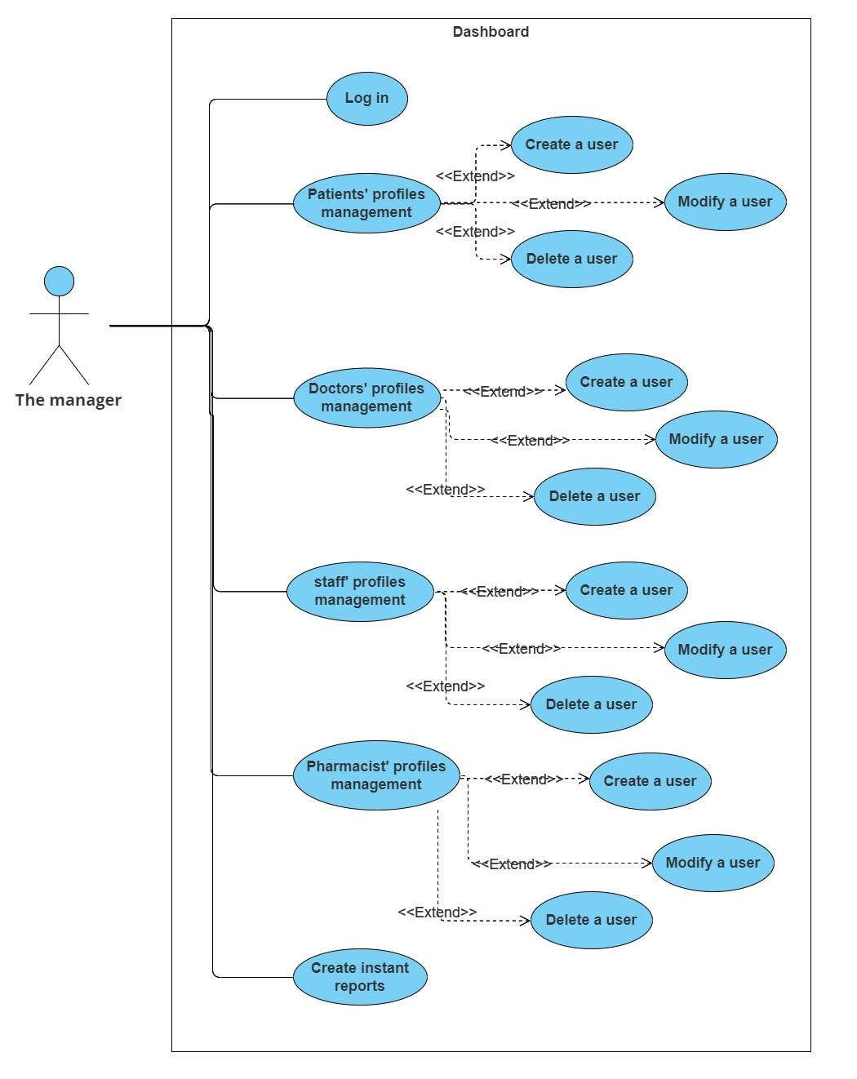

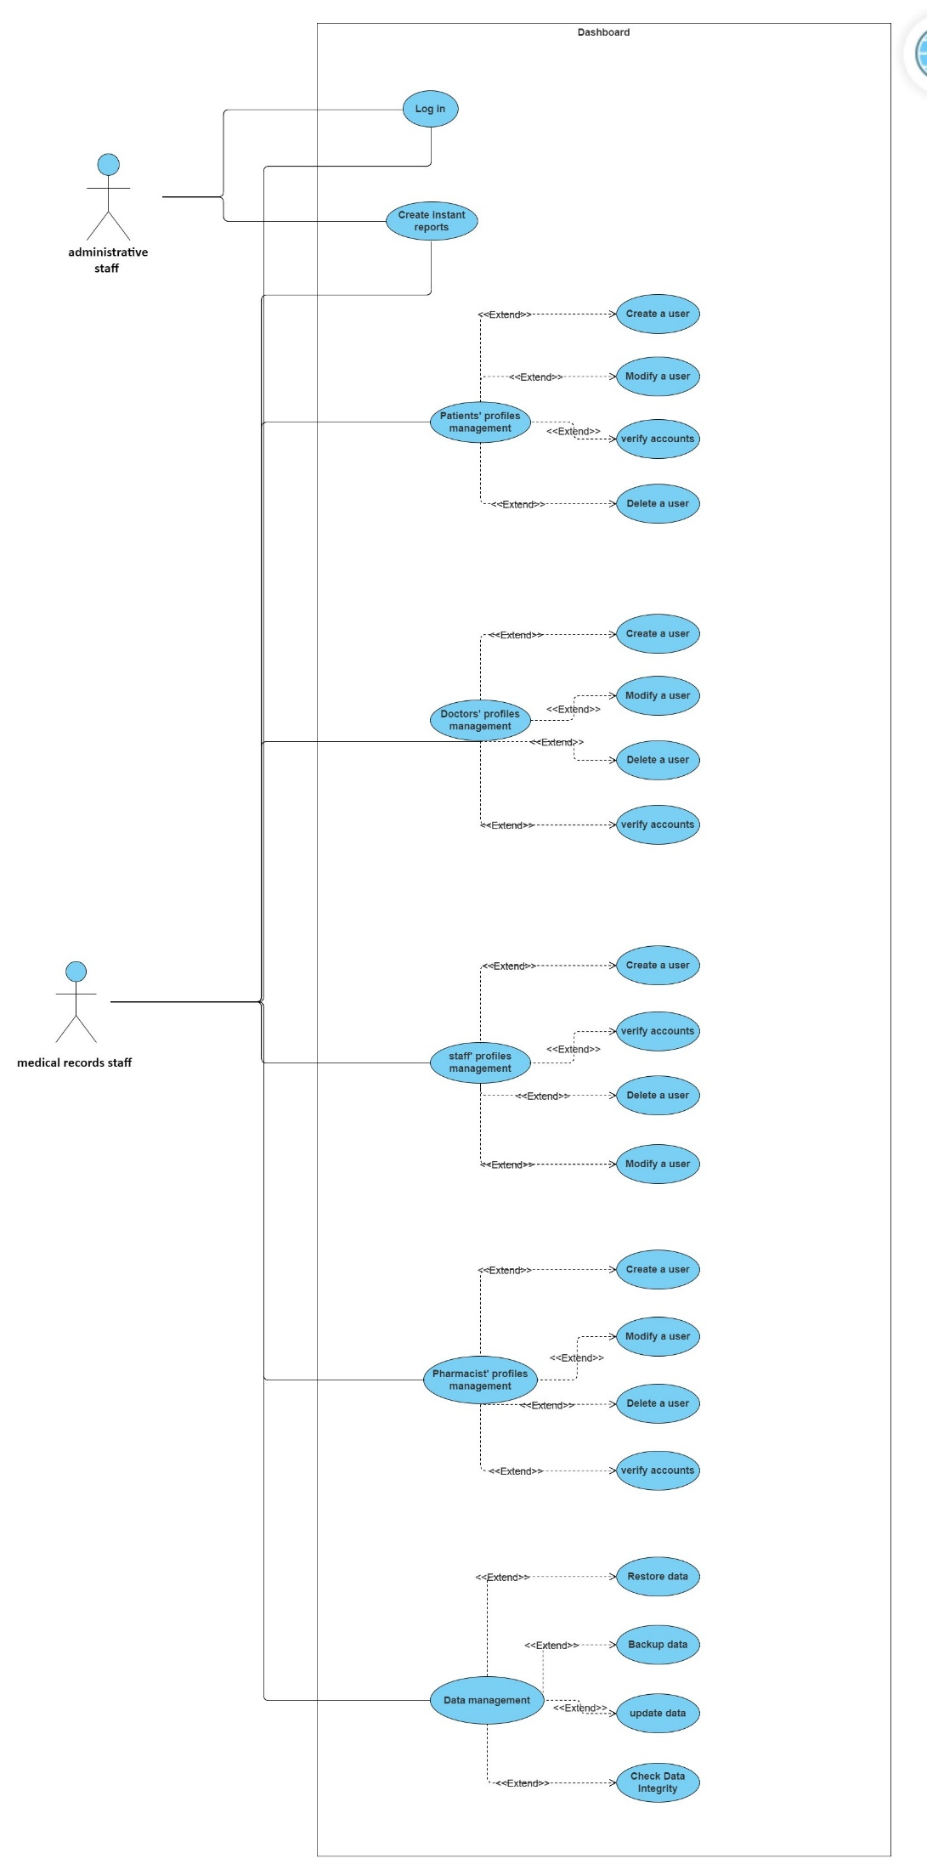

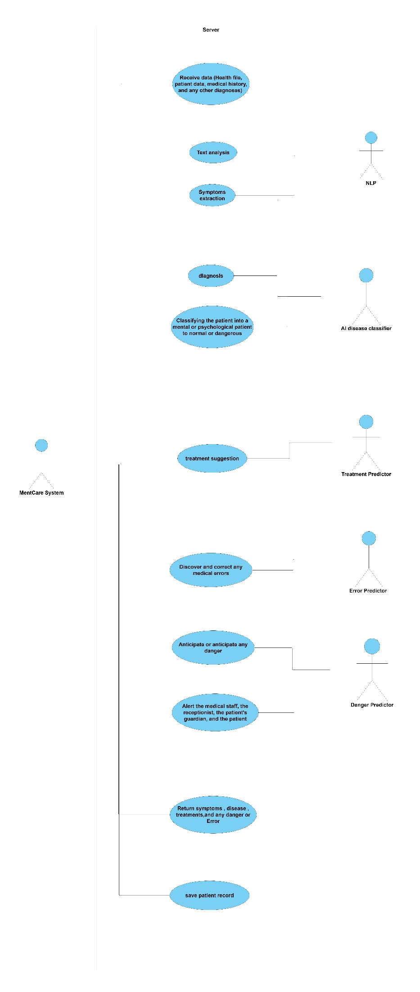

|  |  |
| --- | --- |
| **Use Case ID** |  |
| **Use Case Name** | **Follow-up of the patient and alert the medical staff** |
| **Description** | **The doctor, nurse, and receptionist follow up on the patient’s condition, attend his appointments through the system, and warn the medical staff of any errors or predict the worsening of the patient’s condition.** |
| **Participating actors** | **Receptionist, Patient or Relatives of the Patient, Doctor, Nurse, and Receptionist** |
| **Precondition** | **1- The patient must be registered in the system and his health file is complete and available in the system.** |
| **Trigger** | **The receptionist records the patient's attendance and the doctor enters the progress of his treatment.** |
| **Flow of events** | **1- An SMS message is sent to the patient or his relatives to remind the patient of his reservation.**  **2- The patient's absence is recorded.**  **3- The patient and his relatives are warned not to attend the patient.**  **4- Recording the patient's failure to respond to the warning.**  **5- Warning the medical staff not to respond.**  **6- Confirmation of quarantine or its follow-up.** |
| **Postcondition** | **Following up the patient's condition in the required manner, recording and saving the progress of his treatment, predicting risks correctly, and reducing injuries.** |

